session-based recommender system (mkm-sr)

# library link

<https://github.com/ciecus/MKM-SR>

# basic description

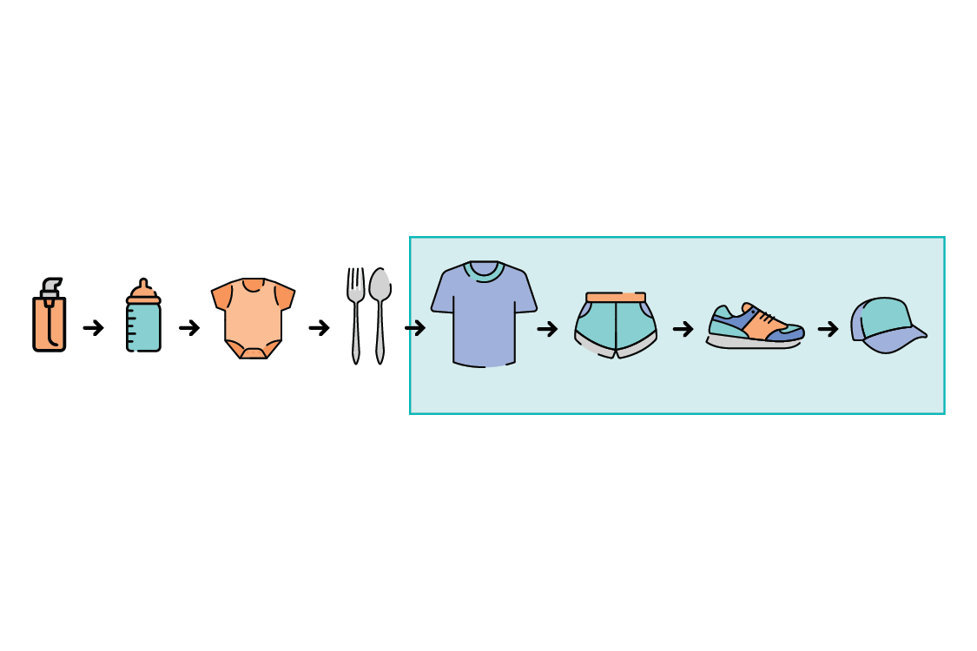

Session-based recommender system refers to a recommendation system that predicts and recommends items to be clicked by a user based on continuous session of a user. The term 'session' here refers to a specific event and mainly refers to a click(log data).

MKM-SR: Incorporating User Micro-behaviors and Item Knowledge into Multi-task Learning for Session-based Recommendation

# version

* Python == 3.6
* Pytorch == 1.6.0 (pip install torch)
* Pandas (pip install pandas)

# dataset

* KKbox

<https://www.kaggle.com/c/kkbox-music-recommendation-challenge/data>

# code description

* Download the code from GitHub.
* Dataset for executing code is in a folder, so there is no need to download it.
* Entering the code below within the MKM-SR folder.

python main.py

# validation

* x